**SQL QUERIES OUTPUT SCREENSHOTS**

set search_path to influencer_partnership

**Q1: Select all columns and all rows from one table (5 points)**

SELECT * FROM content_creation;

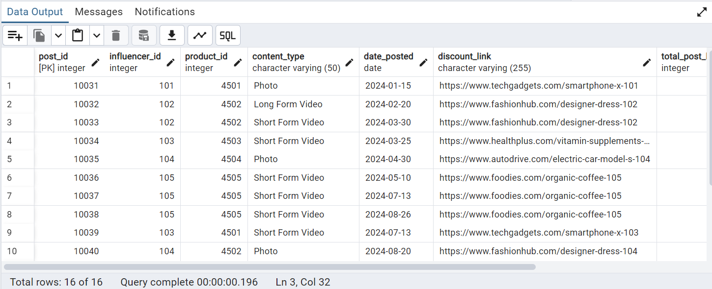

**Q2: Select five columns and all rows from one table (5 points)**

SELECT product_id, product_name, category, price, manufacturer_country

FROM product;

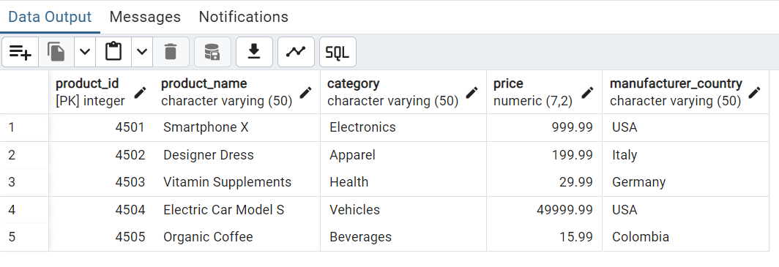

**Q3: Select all columns from all rows from one view (5 points)**

SELECT * FROM ProductInfo;

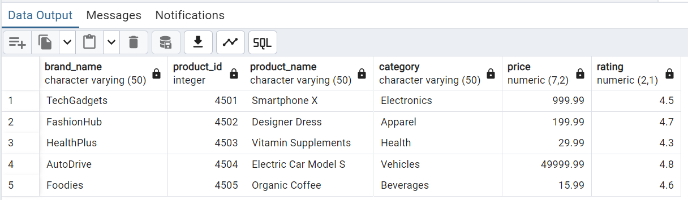

**Q4: Using a join on 2 tables, select all columns and all rows from the tables without the use of a Cartesian product (5 points)**

SELECT * FROM product p

JOIN brand b

ON p.brand_id = b.brand_id ;

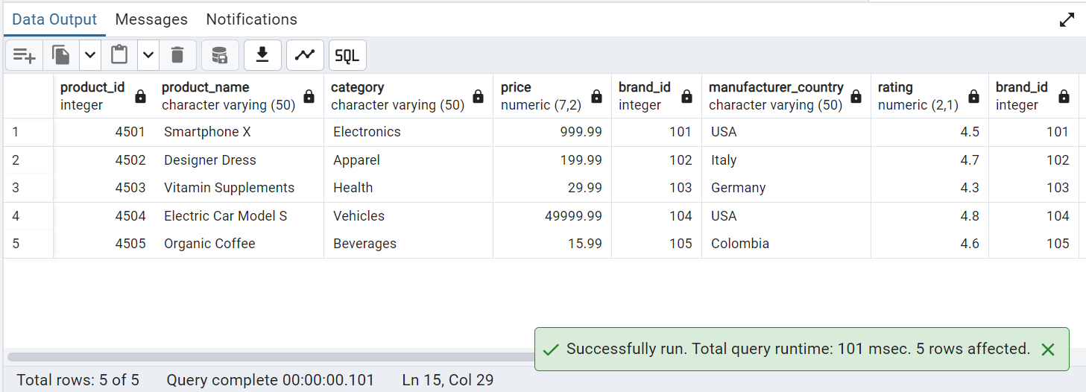

**Q5: Select and order data retrieved from one table (5 points)**

SELECT * FROM contract

ORDER BY pay DESC ;

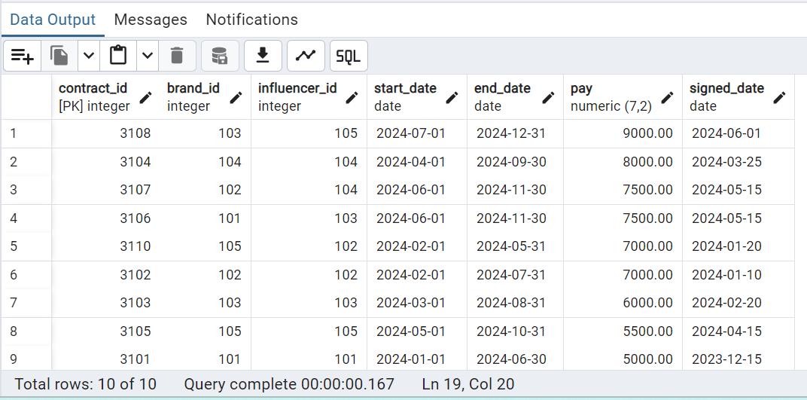

**Q6: Using a join on 3 tables, select 5 columns from the 3 tables. Use syntax that would limit the output to 3 rows (5 points)**

SELECT c.contract_id, i.first_name, i.last_name, p.product_name, p.price

FROM contract c

JOIN influencer i ON c.influencer_id = i.influencer_id

JOIN product p ON c.brand_id = p.brand_id

LIMIT 3;

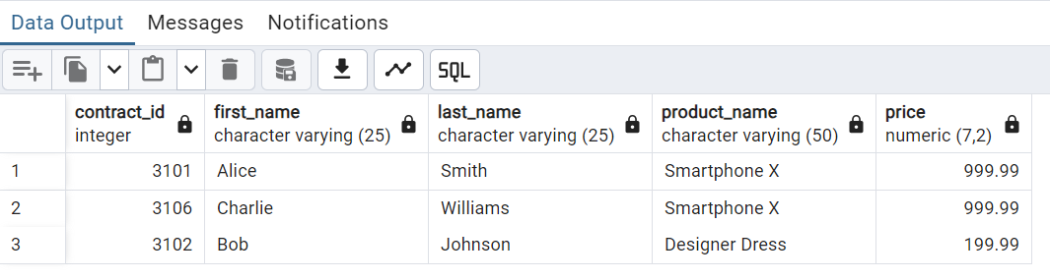

**Q7: Select distinct rows using joins on 3 tables (5 points)**

SELECT DISTINCT i.first_name, i.last_name, p.product_name, b.brand_name, c.pay

FROM contract c

JOIN influencer i ON c.influencer_id = i.influencer_id

JOIN product p ON c.brand_id = p.brand_id

JOIN brand b ON p.brand_id = b.brand_id;

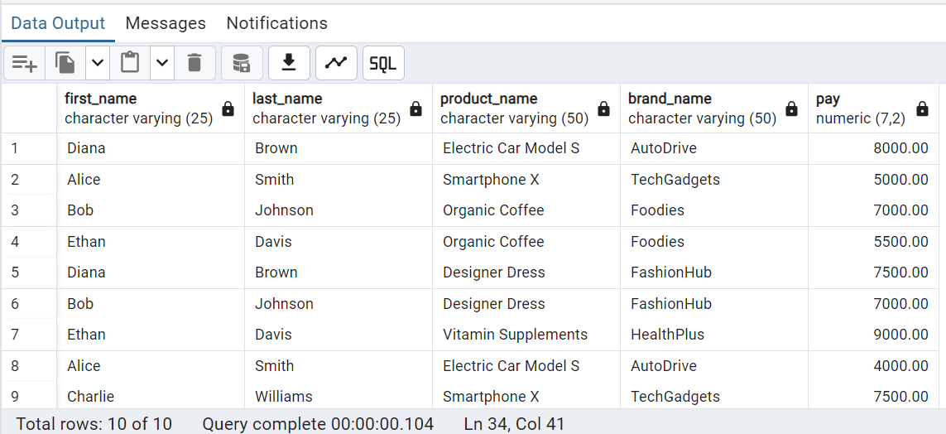

**Q8: Use GROUP BY and HAVING in a select statement using one or more tables (5 points)**

SELECT i.first_name, i.last_name, COUNT(c.contract_id) AS total_contracts, SUM(c.pay) AS total_earnings

FROM influencer i

JOIN contract c ON i.influencer_id = c.influencer_id

GROUP BY i.first_name, i.last_name

HAVING SUM(c.pay) > 10000;

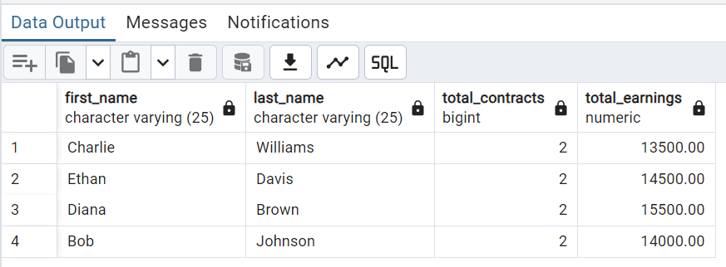

**Q9: Use IN clause to select data from one or more tables (5 points)**

SELECT p.product_name, p.category, p.price

FROM product p

WHERE p.brand_id IN (

SELECT b.brand_id FROM brand b

WHERE b.industry IN ('Technology', 'Fashion')

);

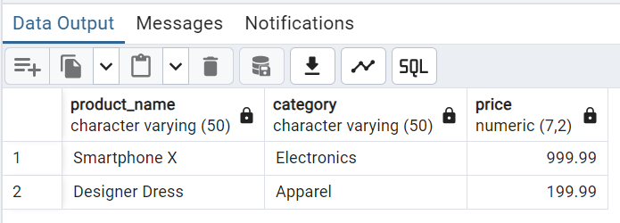

**Q10: Select length of one column from one table (use LENGTH function) (5 points)**

SELECT first_name, LENGTH(first_name) AS name_length

FROM influencer;

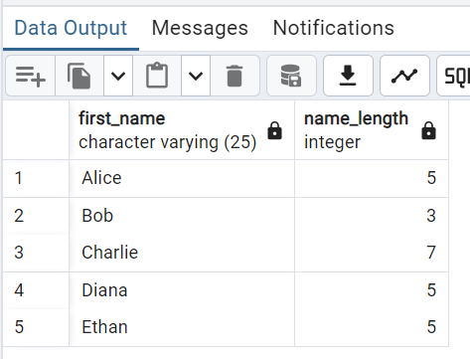

**Q11: Delete one record from one table. Use select statements to demonstrate the table contents before and after the DELETE statement. Make sure you use ROLLBACK afterwards so that the data will not be physically removed (5 points)**

-- View Table Contents Before Delete

SELECT * FROM content_creation;

BEGIN;

DELETE FROM content_creation

WHERE post_id = 10031;

-- View Table Contents After Delete

SELECT * FROM content_creation;

-- Rollback the Transaction

ROLLBACK;

-- Verify Table Contents After Rollback

SELECT * FROM content_creation;

##BEFORE

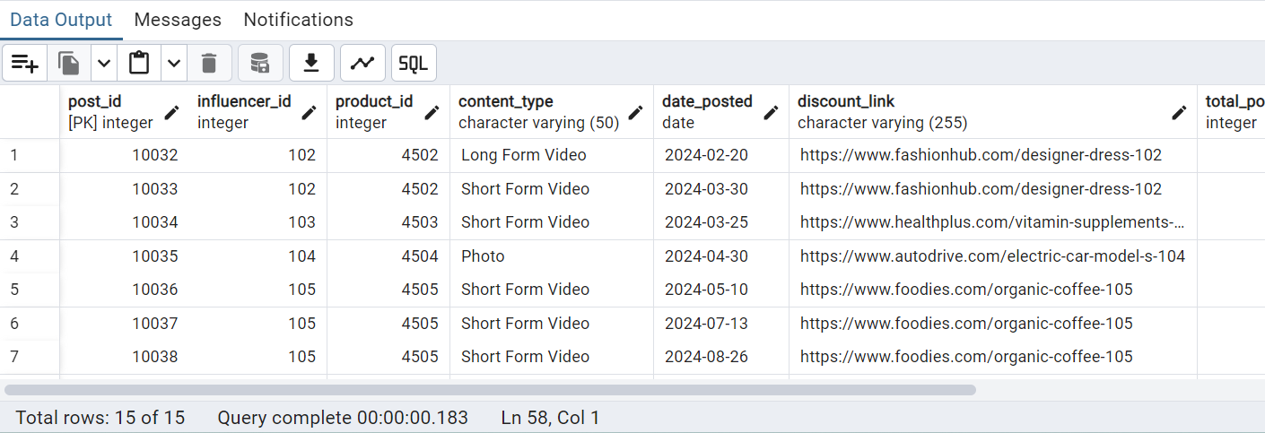

##AFTER

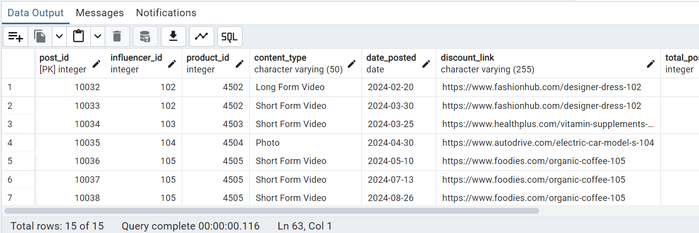

**Q12: Update one record from one table. Use select statements to demonstrate the table contents before and after the UPDATE statement. Make sure you use ROLLBACK afterwards so that the data will not be physically removed (5 points) Update a record and demonstrate using ROLLBACK**

-- View Table Contents Before Update

SELECT * FROM influencer;

-- Start a Transaction

BEGIN;

-- Update a Record

UPDATE influencer

SET platform = 'TikTok'

WHERE influencer_id = 101;

-- View Table Contents After Update

SELECT * FROM influencer;

-- Rollback the Transaction

ROLLBACK;

-- Verify Table Contents After Rollback

SELECT * FROM influencer;

##BEFORE

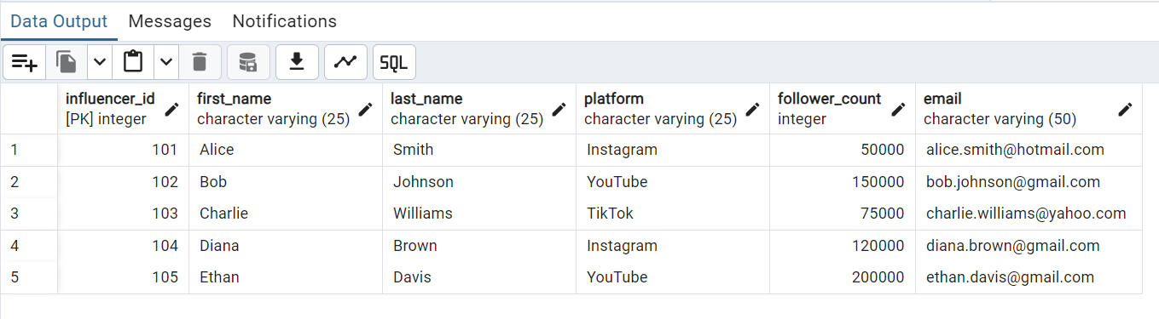

##AFTER

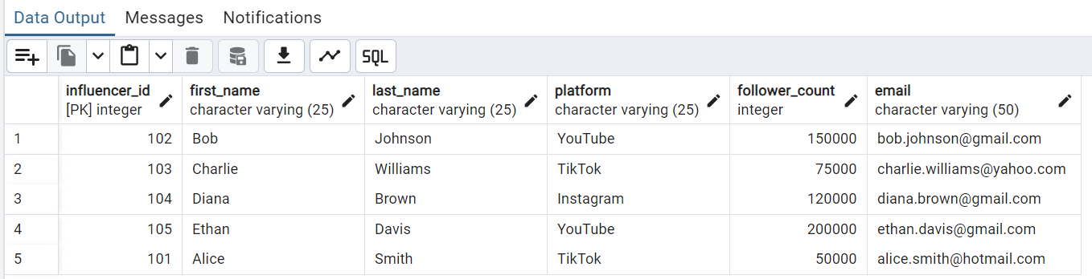

**Q13: Classify each influencer by type (nano, micro, macro, or celebrity) based on their follower count.**

SELECT

i.influencer_id,

i.first_name,

i.last_name,

CASE

WHEN follower_count >= 190000 THEN 'Celebrity'

WHEN follower_count >= 100000 THEN 'Macro'

WHEN follower_count >= 10000 THEN 'Micro'

ELSE 'Nano'

END AS influencer_type

FROM

influencer i ;

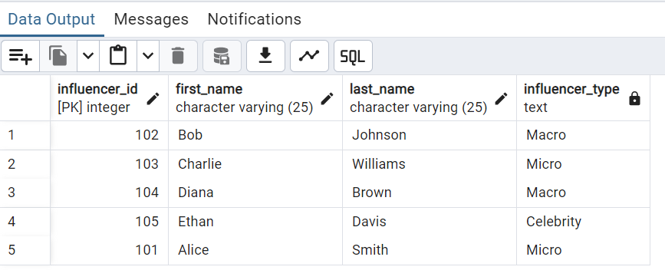

**Q14: Identify the Top 3 Most Profitable Products per Brand**

SELECT

b.brand_name,

p.product_name,

SUM(pm.revenue) AS total_revenue

FROM

product p

JOIN

performance_metrics pm ON p.product_id = pm.product_id

JOIN

brand b ON p.brand_id = b.brand_id

GROUP BY

b.brand_name, p.product_name

HAVING

SUM(pm.revenue) > 0

ORDER BY

b.brand_name, total_revenue DESC

LIMIT 3;

